Domain Sign-In Troubleshooting
Project type: Level 1 IT Support / Active Directory
Ticket ID: HD-SIGNIN-001
Environment: Windows Server + Windows 11 Pro virtual machine
Domain: darshanhome.local
Domain Controller IP: 192.168.1.16 (confirm that this is still your server's current IP before starting)

1. Support Ticket
Ticket title: User Unable to Sign In to the Domain
Priority: Medium
Category: Active Directory / Windows Sign-In
Status: Open — Investigation Required
User report:
A Finance department employee reports that they cannot sign in to their Windows computer using their domain account. The issue started after restarting the computer. The user needs access to their account and departmental files to continue working.
Initial symptoms:
- The user reports a domain sign-in problem.
- The cause has not yet been confirmed.
- The technician must investigate the account, network connectivity, DNS configuration and domain controller discovery before making changes.
Business impact: The employee cannot reliably access their work environment.
Objective: Identify the cause, apply the appropriate fix, and verify that domain sign-in works.

2. Troubleshooting Procedure
Step 1 — Gather information
- The exact error message displayed.
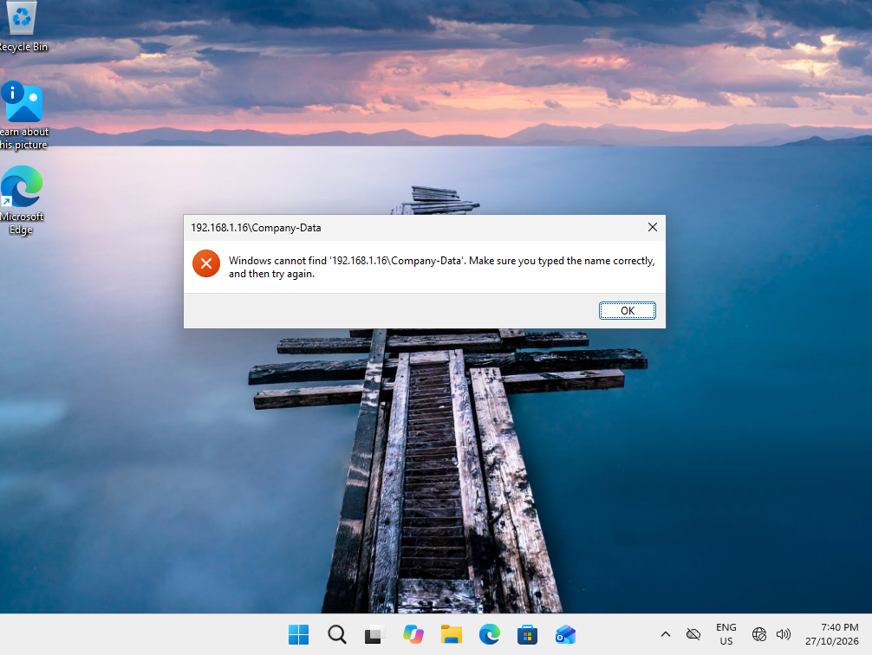
Figure 1 — Error Accessing the Company-Data Network Folder
Description: The user attempted to access the Company-Data network folder from the Windows 11 client and encountered an error. This was recorded as the initial symptom for the troubleshooting investigation.
Initial assessment: The error may be related to DNS resolution, network connectivity, file-server availability, or access permissions. Further testing is required to identify the root cause.
Evidence captured: Screenshot of the error message displayed when accessing the network folder.

- The affected username and computer name.
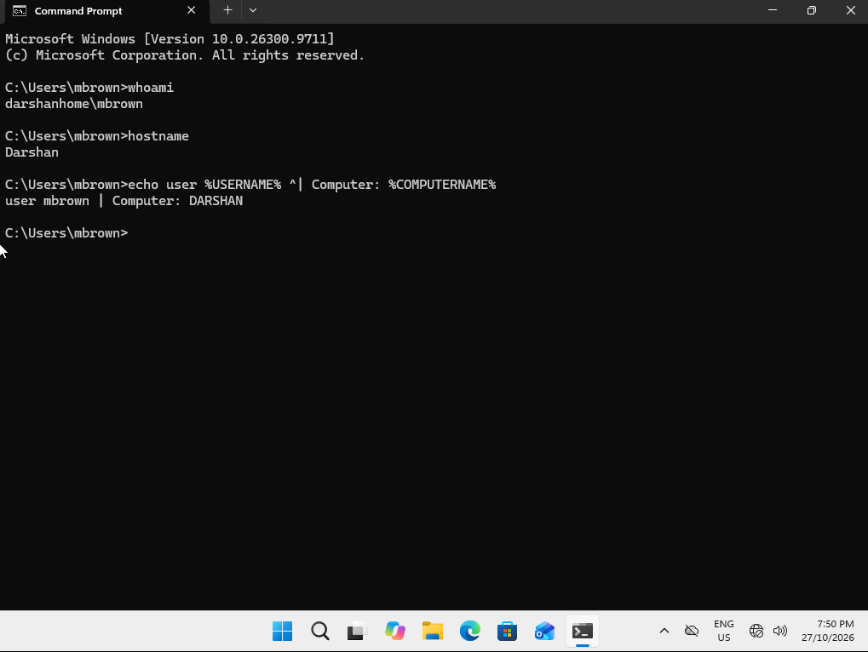
Figure 2 — Identifying the Affected User and Computer
Description: Used Command Prompt commands (whoami, hostname, and environment variables) to identify the currently signed-in user, domain and computer name. This information establishes the affected user and workstation for the troubleshooting investigation.
Evidence captured: Screenshot showing the command outputs for the current username, domain and computer name.

- Whether the issue affects one user or multiple users.
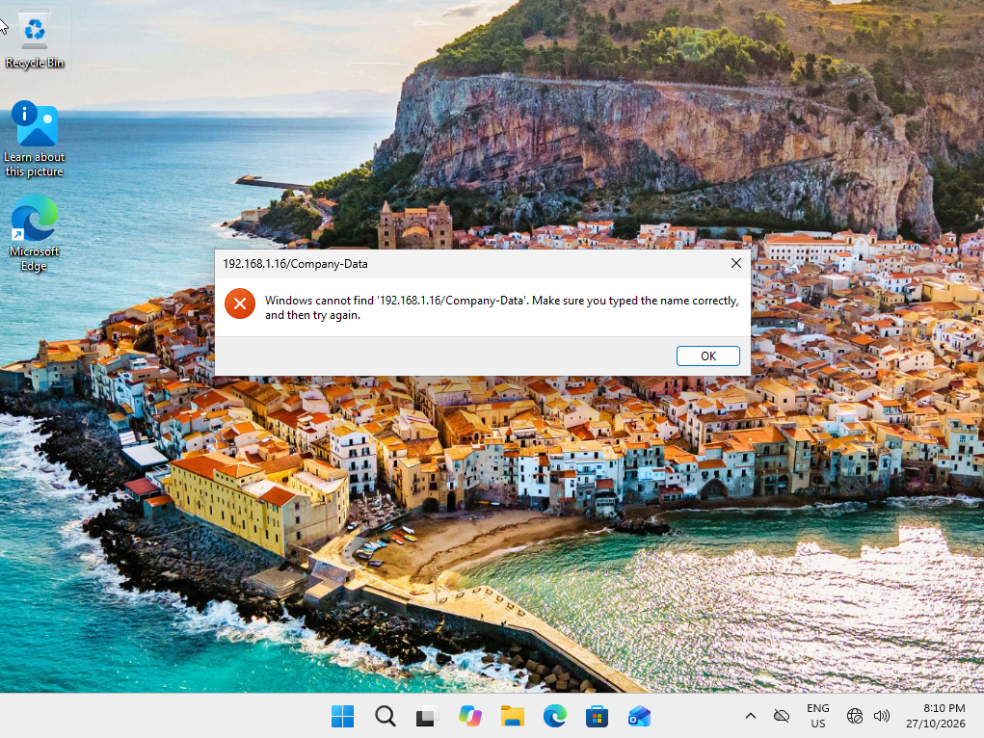
Figure 3 — Verifying Network Folder Access Failure for a Second User

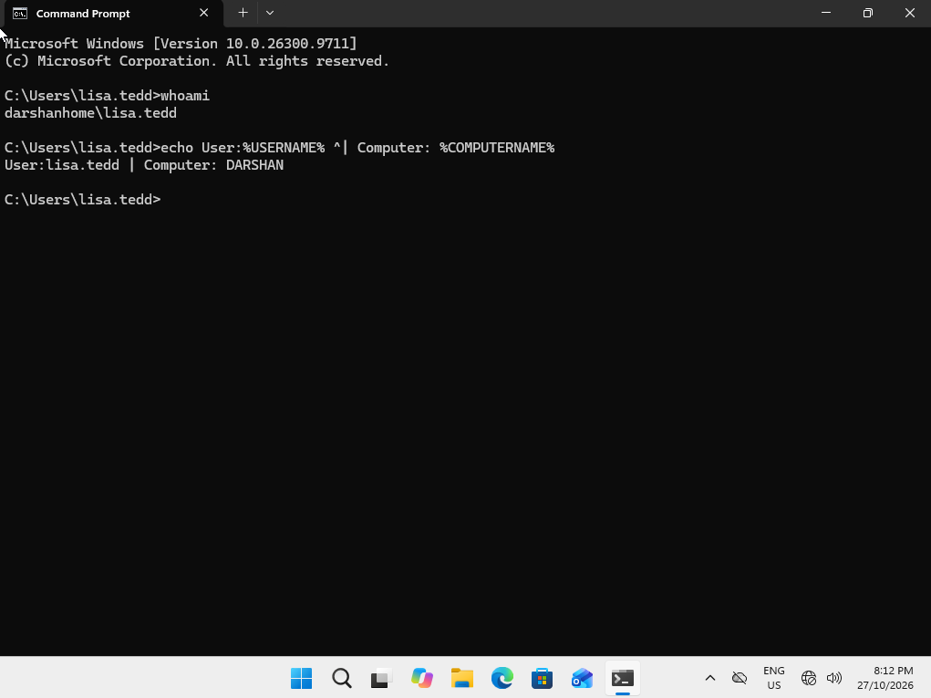
Figure 4 — Identifying the Second User Account and Client Computer

- Whether the user recently changed their password.

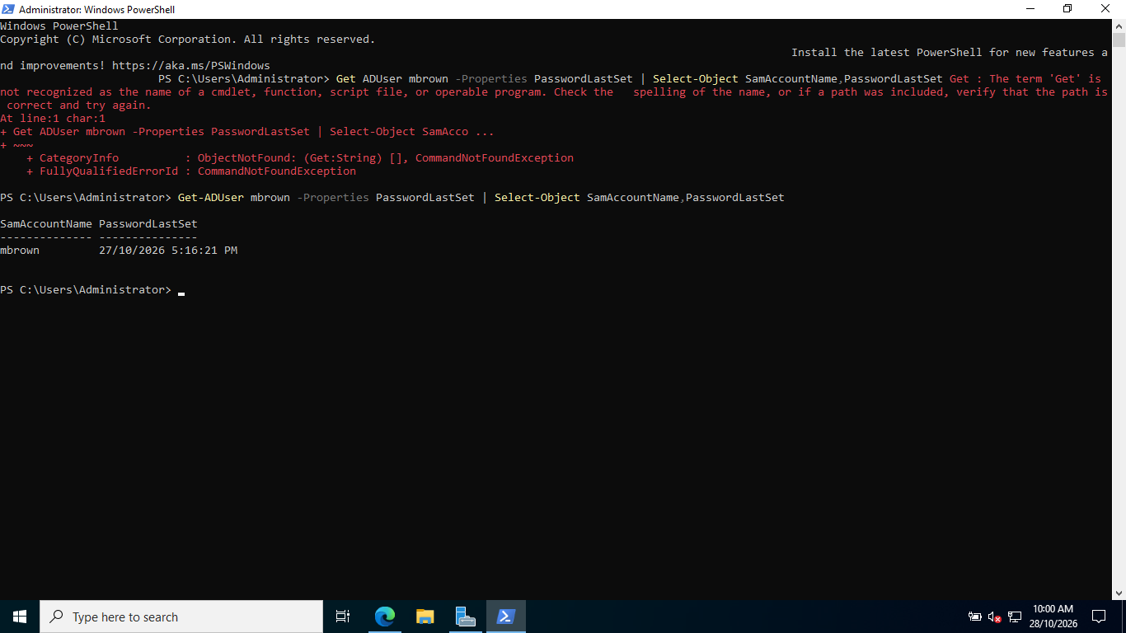
Figure 5 — Verifying the User’s Last Password Change
Used PowerShell to retrieve the affected user’s Active Directory account details and check the recorded PasswordLastSet value. This helps determine whether a recent password change may be related to the reported sign-in issue.
Finding: The account’s recorded last password change was 27/10/2026 5.16.21PM
Note: This timestamp confirms when Active Directory last recorded a password change. It does not, by itself, confirm that the password change caused the issue. Further investigation is required.

- Whether the server is running and reachable.
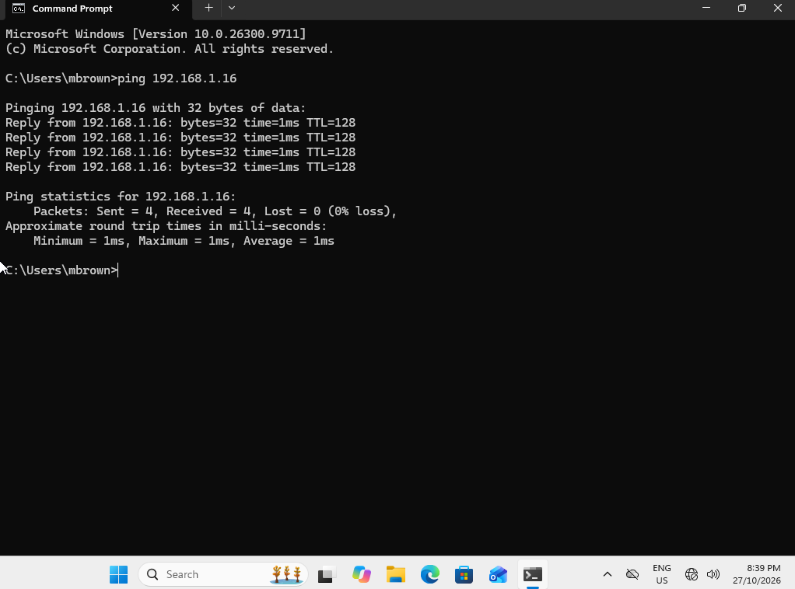
Figure 6 — Testing Server Connectivity Using Ping
Used the ping command from the affected user's account (mbrowm) to test network connectivity to the server.
Assessment: Successful replies indicate that the server's IP address is reachable over the network. However, a successful ping alone does not confirm that Active Directory, DNS, or file-sharing services are operating correctly. A failed ping also does not necessarily mean the server is offline, as ICMP traffic may be blocked.

Step 2 — Check the domain account

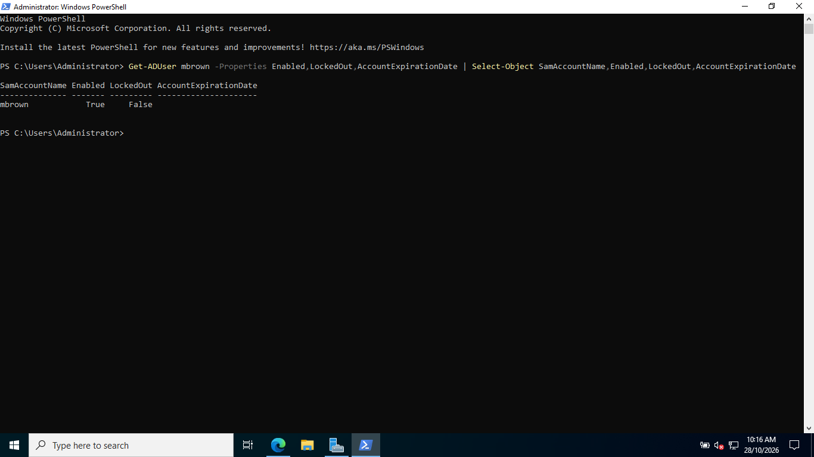
Figure 7 — Verifying Active Directory Account Status
Used PowerShell to inspect the affected user's Active Directory account status, including whether the account is enabled, locked out, and whether the account has an expiry date.
Checks performed:
- Account enabled: Confirmed whether the account is enabled or disabled.
- Lockout status: Checked whether the account is currently locked out.
- Account expiry: Checked whether the account has an expiry date that could affect access.
Finding: mbrown’s account is enabled and not locked out with no expiry date.
Assessment: These checks help identify account-related causes of sign-in problems. If the account is enabled, not locked out, and has not expired, further investigation of DNS, network connectivity, and domain services may be required.

Step 3 — Check the Windows client's IP and DNS configuration
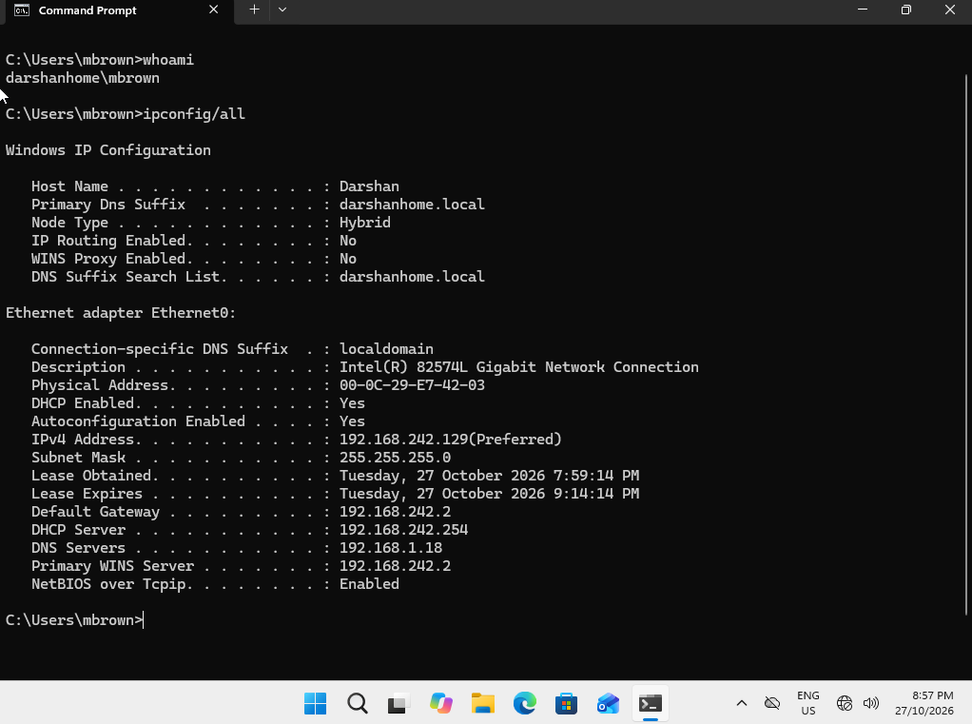
Figure 8 — Checking Windows Client IP and DNS Configuration
Executed ipconfig /all in Command Prompt on the Windows client to inspect its network configuration and identify the IPv4 address, subnet mask, default gateway, DNS servers, and DNS suffix.
Checks performed:
- Verified the client's IPv4 address and subnet mask.
- Checked the default gateway configuration.
- Identified the configured DNS server.
- Reviewed the connection-specific DNS suffix.
Finding: IPv4 address:192.168.242.129 DNS server :192.168.1.18
Assessment: The client should use the DNS server that can resolve the Active Directory domain and locate the domain controller. In this lab, verify whether the configured DNS server is the domain controller's IP address. Incorrect DNS settings can prevent domain discovery and access to domain resources.

Step 4 — Test network connectivity

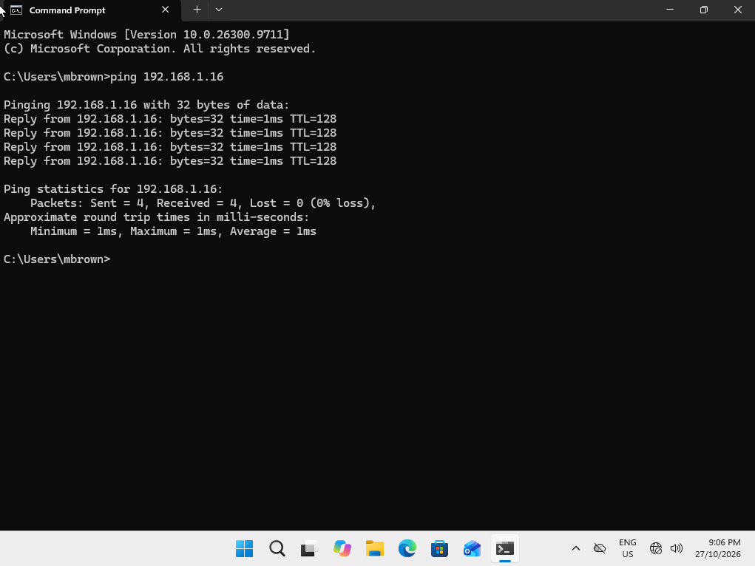
Figure 9 — Testing Network Connectivity from the Affected User’s Account
Executed the ping command from the Windows client while signed in as the mbrown account to test connectivity to the target server.
Purpose: Determine whether the client can reach the server over the network.
Assessment: Successful replies indicate IP-level reachability to the target address. However, this does not confirm that DNS, Active Directory, or file-sharing services are functioning correctly. If the ping fails, further checks are needed because firewall rules or blocked ICMP traffic can also cause failures.

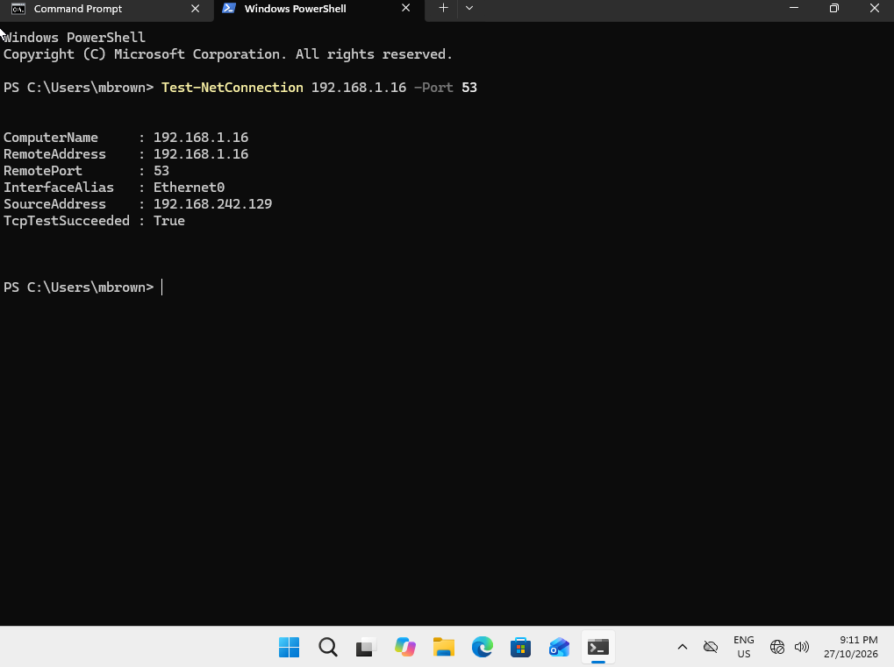
Figure 10 — Testing DNS Port Connectivity Using PowerShell
Used PowerShell to test TCP connectivity to port 53 on the DNS server. This test helps determine whether the client can establish a TCP connection to the DNS service.
Purpose: Check whether DNS connectivity may be contributing to the domain sign-in or network resource access issue.
Finding: TcpTestSucceeded: True
Assessment: A successful TCP test indicates that a connection to port 53 was established. A failed test may indicate a connectivity issue, firewall restriction, or that the service is not listening on that port. However, this test alone does not confirm that DNS queries are resolving correctly.

Step 5 — Test DNS resolution

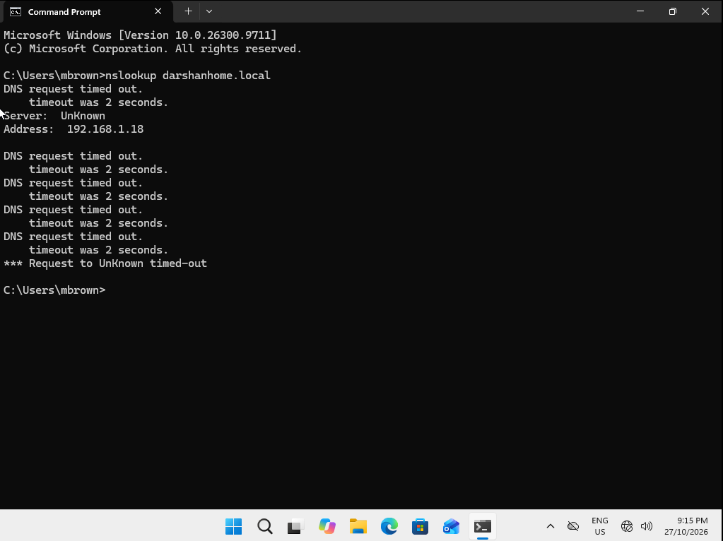
Figure 11 — Testing DNS Name Resolution Using NSLookup
Executed the nslookup command on the Windows client to test DNS name resolution while the client was configured with an intentionally incorrect DNS server address.
Finding: The DNS query timed out, and the client did not receive a response from the configured DNS server.
Assessment: The result is consistent with the simulated DNS configuration issue. Without a working DNS server, the client may be unable to resolve domain names and locate Active Directory services.

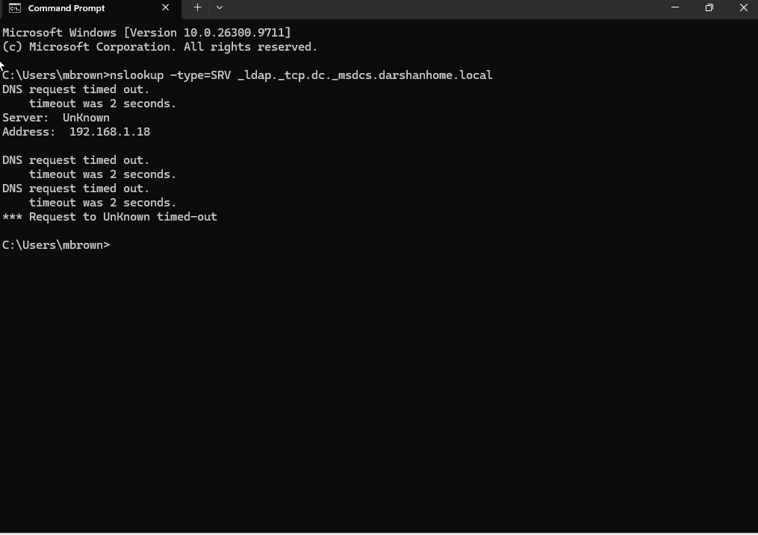
Figure 11 — Identifying a DNS Resolution Failure
Executed an nslookup SRV-record query to investigate whether the Windows client could locate the domain controller for darshanhome.local.
Finding: The DNS query timed out after the client's DNS address was deliberately changed to simulate a domain connectivity issue.
Assessment: The timeout indicates that the client did not receive a DNS response from the configured DNS server within the allotted time. This is consistent with an incorrect or unreachable DNS server, although the timeout alone does not prove the exact cause.

Step 6 — Test domain controller discovery
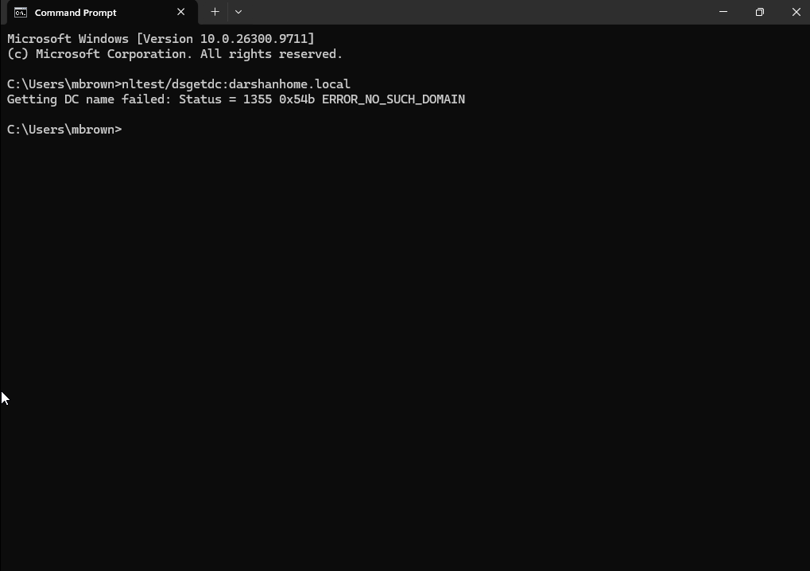
Figure 13 — Testing Domain Controller Discovery Using NLTest
Executed nltest /dsgetdc:darshanhome.local on the Windows client to determine whether the client could locate a domain controller for the Active Directory domain.
Finding: The command returned Error 1355, indicating that Windows could not locate a domain controller for the specified domain.
Assessment: This result is consistent with the simulated DNS configuration issue. Incorrect DNS settings can prevent the client from discovering Active Directory domain controllers. However, Error 1355 alone does not confirm the underlying cause.

Step 7 — Identify and correct the confirmed cause
Root cause identified: The Windows client's DNS configuration was pointing to an incorrect DNS server address instead of the Active Directory domain controller's IP address.
Evidence: The ipconfig /all output showed the incorrect DNS server configuration. DNS lookup commands timed out, and nltest /dsgetdc:darshanhome.local returned Error 1355, indicating that the client could not locate a domain controller.
Corrective action: Updated the Windows client's DNS configuration to point to the correct DNS server hosted on the domain controller.
Validation: After correcting the DNS configuration, repeat the DNS lookup and domain controller discovery tests to confirm that name resolution and domain controller discovery are working correctly.
Outcome: The DNS configuration was identified as the likely cause of the simulated domain connectivity issue. The issue should only be marked as resolved after the validation tests succeed.

Examples:
- Incorrect DNS configuration: Correct the client VM's DNS settings so it uses the domain controller's DNS service.
- Account locked: Follow the appropriate account-unlock procedure after checking the cause.
- Account disabled: Confirm authorisation before re-enabling it.
- Network connectivity issue: Correct the relevant VM network configuration or escalate if the cause is outside your access.
- No confirmed cause: Continue testing or escalate rather than guessing.
If you deliberately introduce an incorrect DNS setting to practise, do so only on the client VM. Record the original setting and restore the correct DNS configuration afterward.
After correcting DNS, you can refresh the client's DNS cache:
ipconfig /flushdns
Then repeat the DNS lookups and domain controller discovery tests.
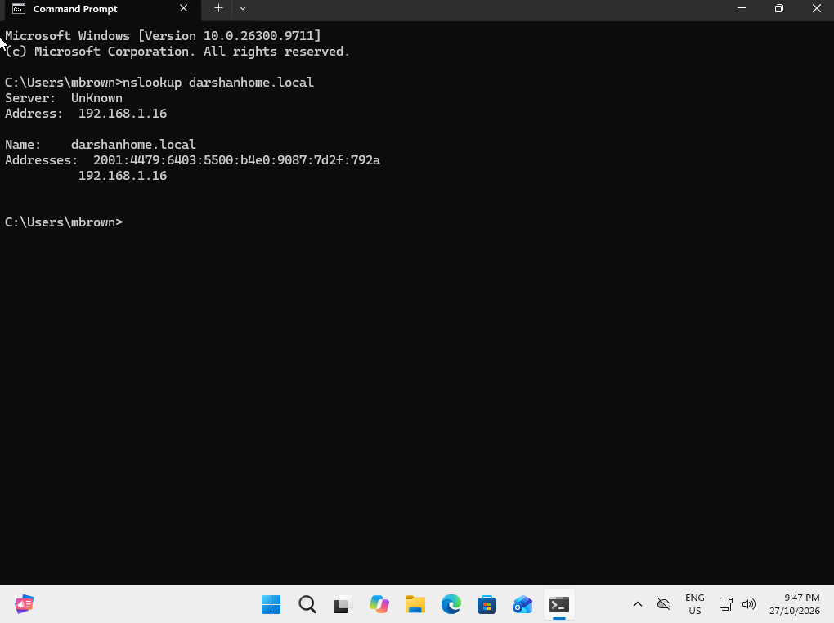
Figure 14 — Verifying DNS Resolution After Correcting DNS Configuration
After updating the Windows client's DNS server address to the correct domain controller DNS server, reran nslookup to verify DNS name resolution.
Finding: The DNS query completed successfully and returned a response from the DNS server.
Assessment: The successful result confirms that DNS queries are now receiving responses after the configuration was corrected. This supports the diagnosis that the incorrect DNS configuration contributed to the original issue.

Figure 15 — Verifying Successful Domain Controller Discovery
After correcting the Windows client's DNS configuration, executed nltest /dsgetdc:darshanhome.local to verify that the client could locate a domain controller for the Active Directory domain.
Finding: The command completed successfully and returned information about the domain controller.
Assessment: Successful domain controller discovery confirms that Windows can locate a domain controller for darshanhome.local. Combined with the successful DNS and SRV-record lookups, this supports the conclusion that the incorrect DNS configuration caused the original domain discovery failure.
Outcome: The client’s DNS configuration was corrected, and domain controller discovery was successfully restored in the lab.

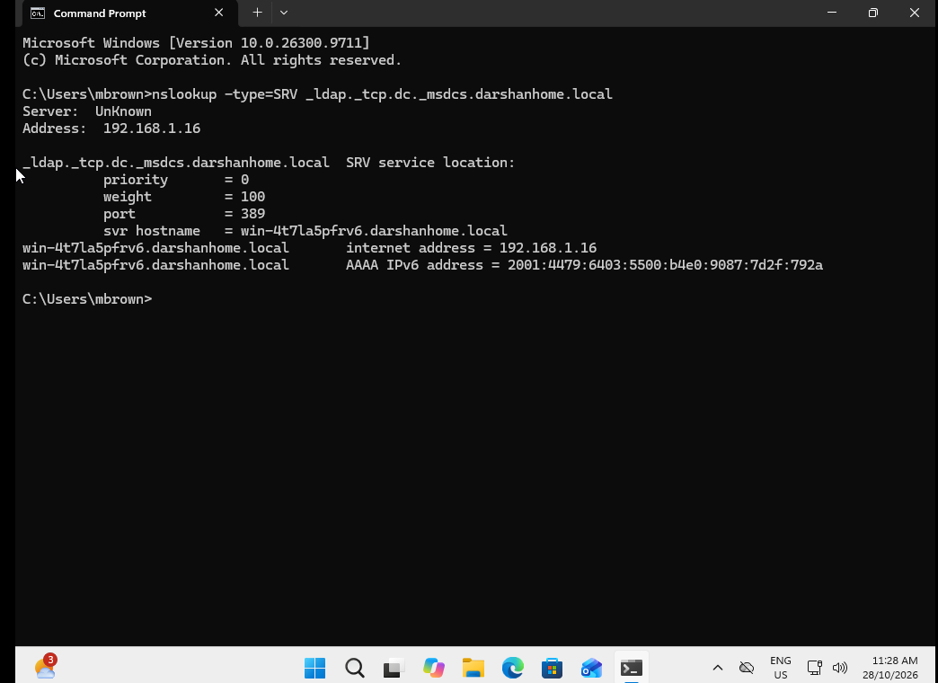
Figure 16 — Verifying Active Directory SRV Records After DNS Correction
After correcting the Windows client's DNS server configuration, reran the SRV-record lookup using:
nslookup -type=SRV _ldap._tcp.dc._msdcs.darshanhome.local
Finding: The query successfully returned the Active Directory SRV records.
Assessment: The successful result confirms that DNS is returning the requested service records, helping the client discover the domain controller for darshanhome.local. This supports the conclusion that correcting the DNS configuration resolved the DNS lookup failure.

Final validation: Retest access to the Company-Data network folder to confirm that the original user-facing issue is resolved.

Evidence to capture: The setting before and after the change, plus the repeated test results.
Step 9 — Verify domain sign-in
After the fault is corrected:
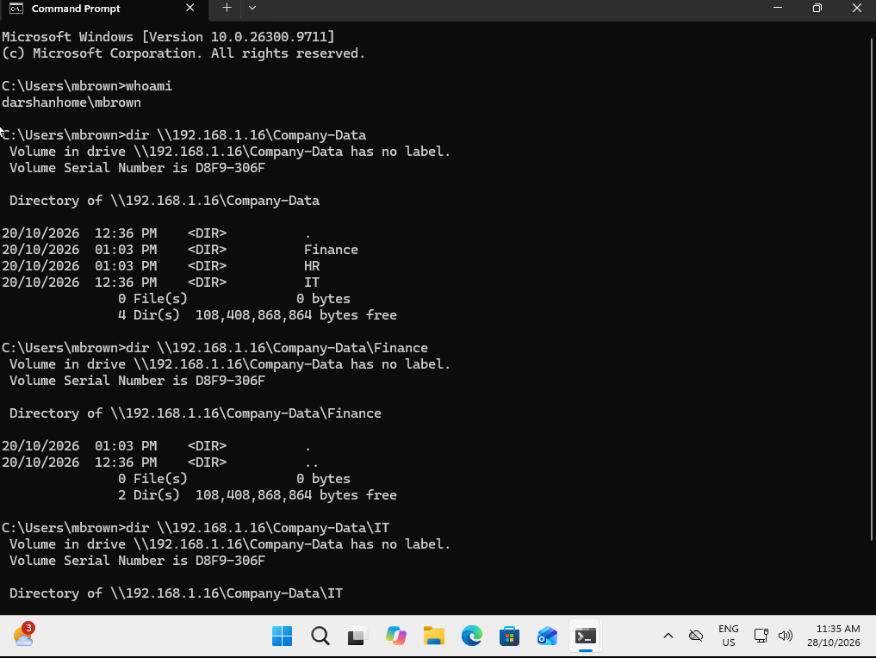

Figure 17 — Verifying Domain User Identity and Network Folder Access
After correcting the client's DNS configuration and confirming successful domain controller discovery, used Command Prompt to verify the signed-in user with whoami and tested access to the Company-Data network folder.
Finding: The command confirmed the signed-in user identity, and the user successfully accessed the network folder.
Validation: The successful folder access confirms that the original network resource access issue was resolved for the tested user account.
Outcome: Correcting the DNS configuration restored domain controller discovery and enabled the tested user to access the network folder successfully.

4. Final Ticket Resolution
Resolution summary:
Investigated the reported domain resource access issue by checking the user's Active Directory account status, password change history, client IP and DNS configuration, network connectivity, DNS resolution, and domain controller discovery.
Confirmed root cause:
The Windows client was configured with an incorrect DNS server address. This prevented successful DNS queries and domain controller discovery, as evidenced by DNS timeouts and nltest returning Error 1355.
Corrective action:
Updated the Windows client's DNS server configuration to point to the correct DNS server hosted on the domain controller.
Verification:
- Standard nslookup completed successfully after the DNS correction.
- The Active Directory SRV-record lookup successfully returned the required service records.
- nltest /dsgetdc:darshanhome.local successfully located the domain controller.
- The whoami command confirmed the signed-in user identity.
- The tested user successfully accessed the Company-Data network folder.
Final status: Resolved — Verified in Lab Simulation.

